Ex. A Spot the inconsistencies: List the things in the pictures that should not take place.
Ex. Due bambini stanno giocando vicino alla serra. (Two kids are playing near a greenhouse).

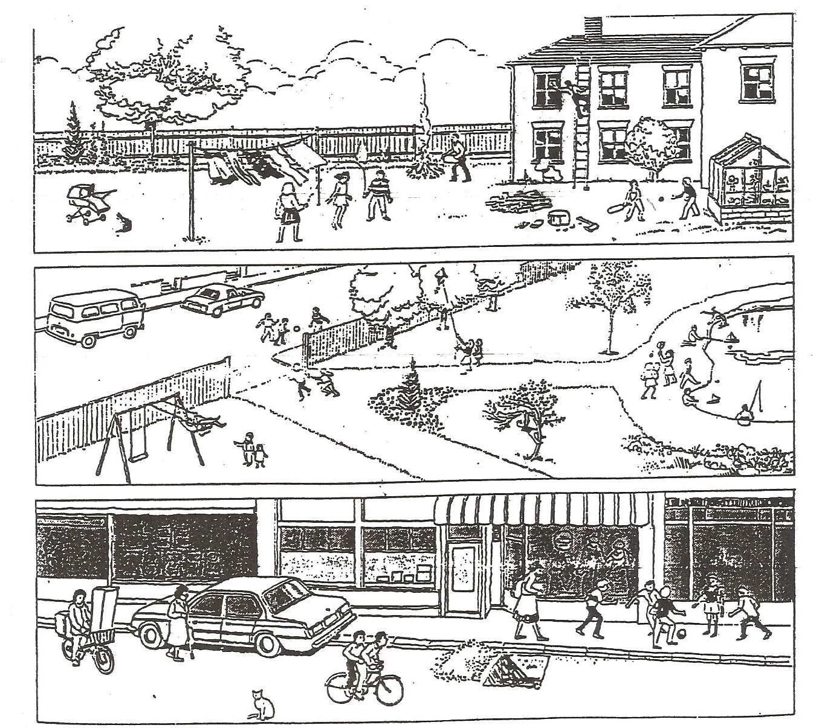USEFUL VOCABULARY: carrozzino = strolley; corda = rope; falo’ = bonfire; scala = ladder; accetta = axe; altalena = swinger; arrampicarsi = to climb; aquiline = kite; laghetto = pond; vetrina = shopwindow.

Ex. B. Write 5 good questions related to the pictures. Use the present continuous tense as much as you can.
Ex. A che cosa stanno giocando i 2 bambini vicino alla serra nella prima figura?

