Manuel Garcia
Period 1A
AP Italian
La Nostra Gita

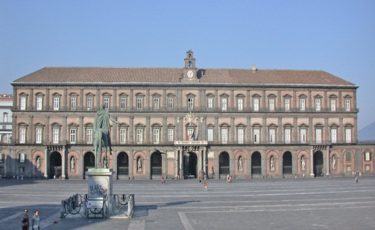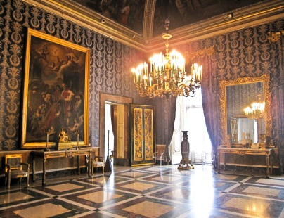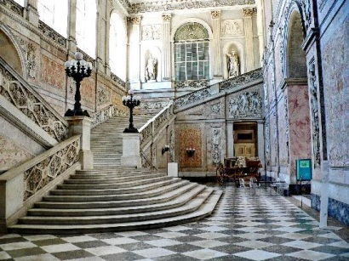
Although yesterday felt like one of the coldest days that has come to Naples, it was a great study trip and I really enjoyed myself with all of my American and new Italian friends. After about a 20 minute bus trip to the Palazzo Reale, we unloaded off the bus and stood in front of this grand palace. We looked all around the palace and admired it’s wonderful beauty; taking the time to appreciate all of the beautiful architecture and incredible size of the Piazza del Plebiscito. As we waited for our class of Italian friends to arrive from the San Giorgio a Cremano, we walked around the grounds of the Piazza and took an abundant supply of pictures to show our families and tell them about this amazing spectacle. Once the class of Italians came, we were greeted immediately with much hospitality and admiration from all of the students, instantly taking pictures together and we told all about the history of this very historical site in Naples. We were told of the infamous story about the four statues in front of the Palazzo, and also played a sort of game to blindfold a student and make try to find his way between two statues from quite a distance away. We also learned that Naples was the capital of Italy before Rome, and was also the center of trade and commerce for the southern half of the country. After spending close to an hour in the cold Neapolitan wind, we were very cold and were ready to enter the Palazzo Reale. I have memories of this place from when I was a child living in Naples and have not forgotten all of the wonderful architecture and paintings that were found inside. Even though I have been there before, once we stepped inside the view of the grand staircases leading up the Palazzo and the sheer size of the statues took your breath away. We walked the Palace and learned the historical information about the ballroom, theatre, and other significant rooms that were scattered throughout the Palace. We toured the Palazzo Reale for about an hour, and once we were educated about the reign of the kings and Bill Clinton’s visit to this monument, we walked outside and started making out way to the Castel del’Ovo. The name Castel del’Ovo in Italian means “Egg Castle” because of a famous story that is really quite interesting. Our tour guides told us that before the castle was constructed, the King ordered an Egg to be placed under the foundation. It was believed that if the egg was broken before the castle was completed, then many years of bad luck and misfortune would come to the city of Naples; fortunately the egg was intact by the date of it’s completion. We all took a lot of pictures from the top of the castle and practically kissed the sea air that was blowing just outside of the castle walls. The warm Neapolitan pizza for lunch was the best way to end the day and warmed us all up after a full day in the cold weather. This was a very memorable field that I found very interesting and refreshing. I made a lot of new friends and learned many things that I didn’t know about this magnificent city. I hope to take my American family when they come visit me. I couldn’t have asked for a better way to spend the day!
